Welcome
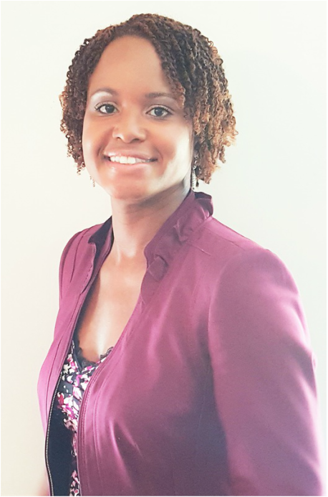
Leaving my full-time job in corporate America, I figured I’d do what I’ve always done and secure employment within no time.
Little did I know God had another plan.
He made a way for Him to get me alone, with no distractions, undisturbed, fully focused on Him and His Word.
I pause as I write that to say…
“Wow!”
How often can one say, my Dream, my Call, His Purpose, His Plans for my life are so great, I needed a period of completely uninterrupted time for Him to prepare me in what I call ‘Spiritual Boot camp’.
The birthing of the vision all started with a conversation with Pastor Robert L. Campbell of New Beginning Christian Church, who eventually became my Pastor, about Excellence in Ministry and upholding the same high standard of operations within the church that we expect to see in corporate America. We go to work every day and come to church on Sunday with what we have left.
Which sometimes is not our best.
​
That conversation led to me conducting a five-hour training to ~100 of his Division and Department Leaders, Elders and volunteers on Excellence in Ministry, Effective Change Management, Resilience in Times of Change and Your Role in the Greater Vision.
I shared the importance of operationalizing unity and excellence to set expectation and accountability on how you are to operate one to another and the level of commitment expected to serve. I walked them through the demands of excellence physically, mentally and spiritually.
I communicated the importance of establishing frameworks that create a safe environment for individuals to grow and operate in their gifts and talents, both individually and as a team.
Once these frameworks are established, they level the playing field allowing everyone to operate fully within the boundaries of each framework.
After the training, I worked with the leaders and teams to build sustainable and repeatable process and procedures. Also introducing them to a calendaring system designed to create complete transparency of their short and long range planning, connecting everything back to the greater vision.
In this, unexo! was birthed!
With unity and excellence being operationalized as the framework to under gird it all.
The unexo! system is all about helping people work better together. The system facilitates improved teamwork, greater vision alignment, streamlined process and procedures and transparency in long and short range planning.
The unexo! framework is the core of the unexo! system. It is a framework in which unity (who we are together) and excellence (standard in which we operate) is operationalized.
As I worked through this with the church, God impressed upon my heart to take this system and framework to other churches. Helping them bring greater structure and order within the four walls of the church, freeing them up to get outside the four walls and have a greater impact on their communities.
I have seen and experienced the effectiveness of the system and framework in the church environment. This effectiveness was confirmed by Pastor Campbell………………………
I am certain it will also be equally as effective in other segments as well.
My desire is to help start-ups, small businesses, and team leaders who are just as passionate as I am about creating safe environments were their team members’ gifts and talents can flourish. I want to work with leaders who are seeking a level of transparency in their day to day operations that empowers team members to work at their highest level of their personal best. These leaders desire creativity in solutions and innovation in thoughts.
While in corporate America, I led several teams to achieve years of sustained repeatable success.
I also know how hard it is to implement programs like this if there is no buy in from the top.
My ideal clients are those leaders with a vision for this type of operationalized unity and excellence, who are open to allow me to partner with them in the full adoption, integration and assimilation of the unexo! system.
As I told the Pastor before we started, “With the system comes exposure. If you are not ready to work through the process to get the team within the framework, let’s not get started”.
His response was, “I’m all in!"
The rest is history!
Literally, HIS story of transformation!

